

Name :Muhammad Shaheer

Roll no: 20p-0480

Lab task: 5

NATIONAL UNIVERSTIY OF COMPUTER AND EMERGING SCIENCES, FAST- PESHAWAR CAMPUS

**TASK 1(Configuring DHCP server on a Router)**

**STEPS:**

1.Make network topology like this.

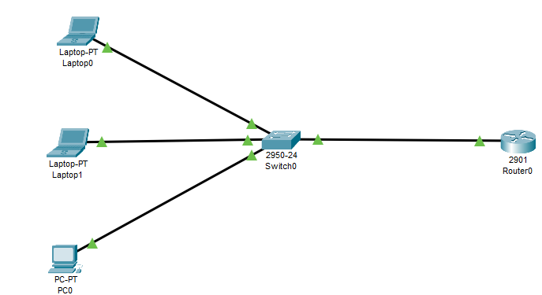

NETWORK TOPOLOGY-1

2.NOW do CLI configuration of router

On the router, configure interface fa0/0 to act as the default gateway for our LAN.

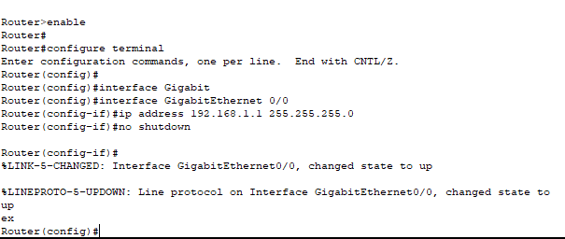

**Router Configuration**

**3.MAKING POOL:**

Configure DHCP server on the Router. In the server we will define a DHCP pool of IP addresses to be

assigned to hosts, a Default gateway for the LAN and a DNS Server.

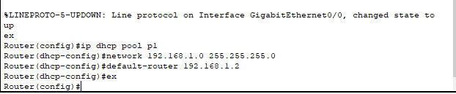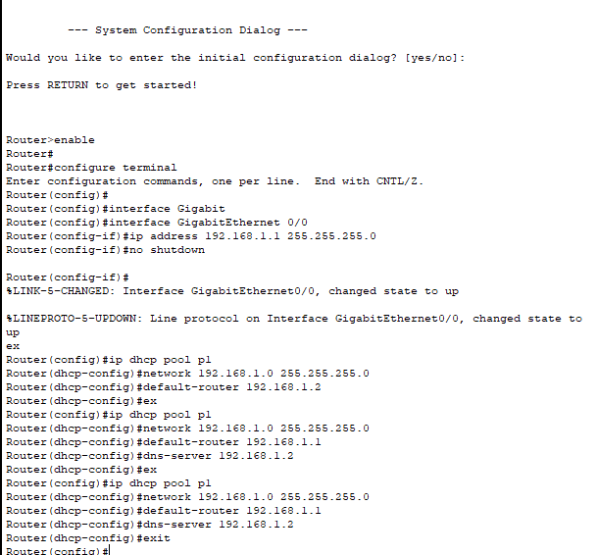

**Configure DHCP server**

4.Now lets check is IP request is successful or not by DHCP

For Device 1:

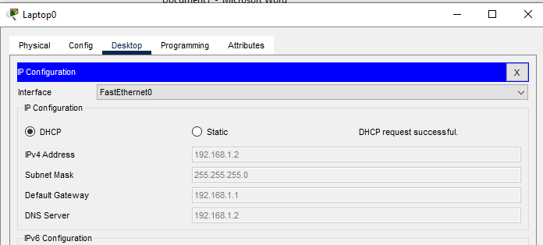

For device 2:

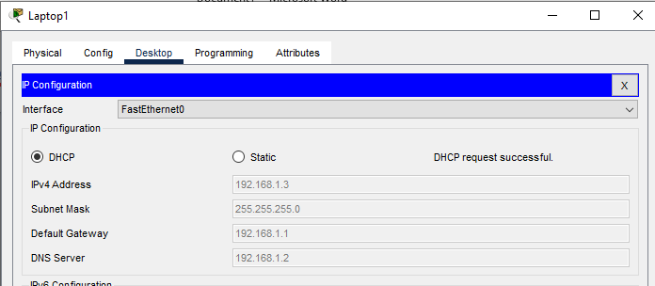

For Device 3

: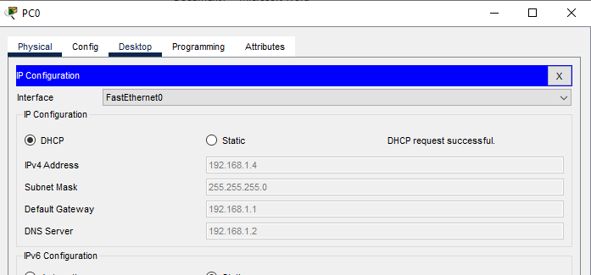

**TASK 2(Configuring DHCP server on a Generic server)**

**STEPS:**

1.Make network topology like this

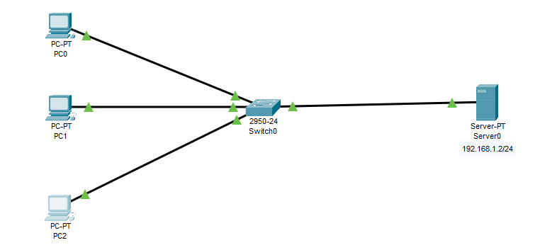

**Network Topology 2**

2.SERVER CONFIGURATION

1. Configure static IP address on the server (192.168.1.2/24).

2. Now configure DHCP service on the generic server.

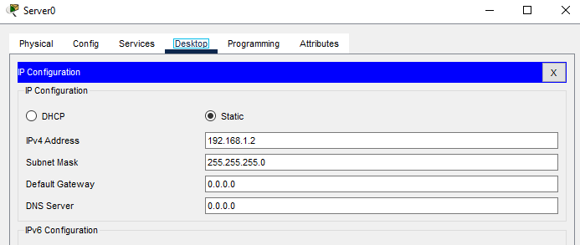

Assign the Ip Address to DHCP

3.SERVER POOL configuration

To do this, click on the server, then click on Services tab. You will pick DHCP on the menu. Then

proceed to define the DHCP network parameters as follows:

* Pool name: serverPool
* Default Gateway: 192.168.1.1
* DNS Server: 192.168.1.3
* Start IP Address: 192.168.1.11
* Subnet Mask: 255.255.255.0
* Maximum Number of users: 245

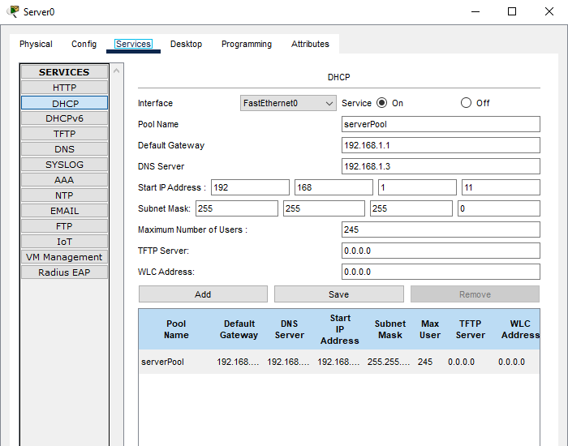

**SERVER CONFIGURATION**

4.Now go to each PC and on their IP configuration tabs, enable DHCP. Every PC should be able to obtain

an IP address, default gateway and DNS server, as defined in step 2. For example, to enable DHCP on

PC1: Click PC1->Desktop->IP configuration. Then enable DHCP:

For PC 0:

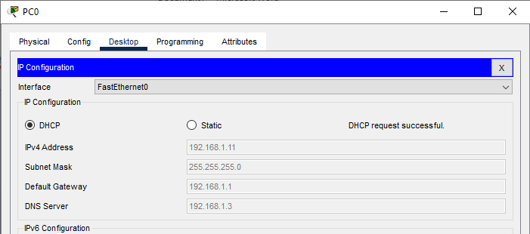

For PC 1:

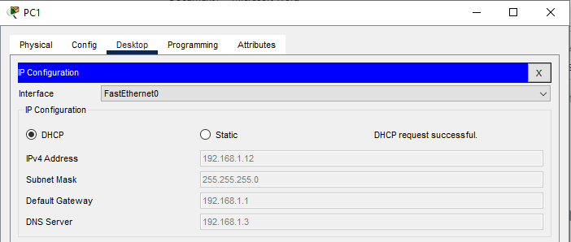

For PC 2:

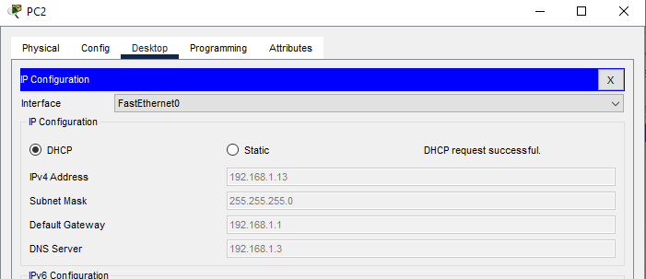

TASK 3

Sub tasks

Task 1: Configure DHCP server on a Router

Task 2: Configure DHCP server on a Generic server

Task 3 : Configure static path and centralized DHCP server

1.Make network topology like this

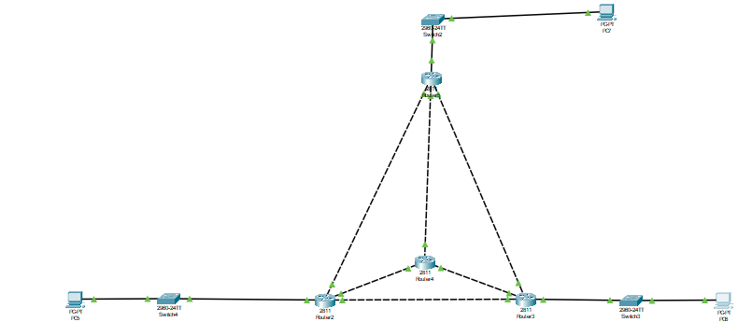

For Router 1:

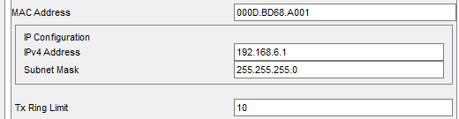

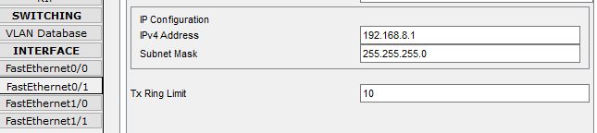

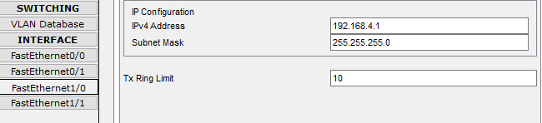

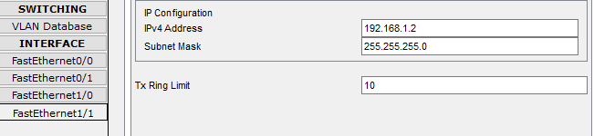

**STATIC ROUTING:**

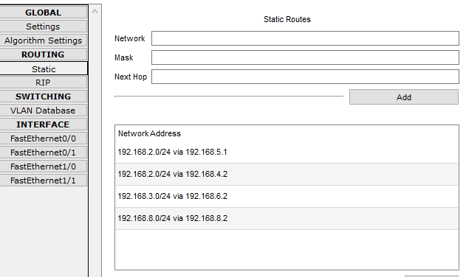

For Router 2:

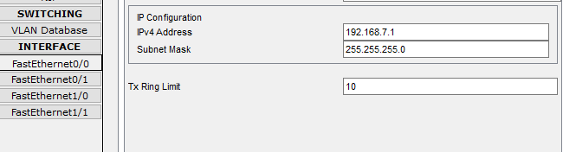

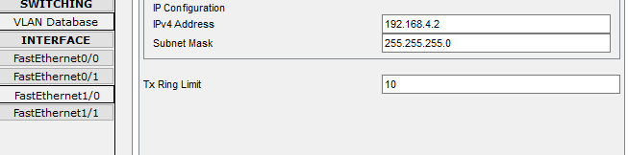

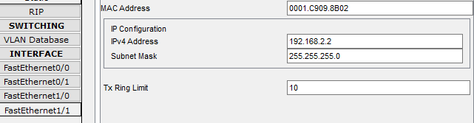

**STATIC ROUTING:**

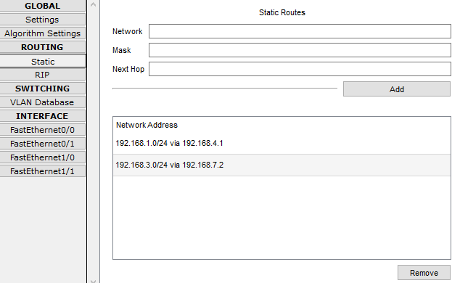

For Router 3:

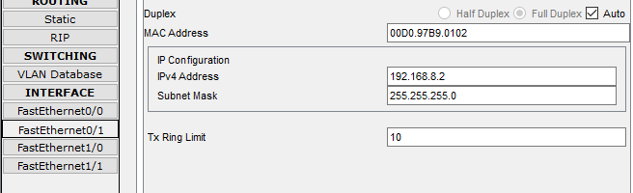

**STATIC ROUTING:**

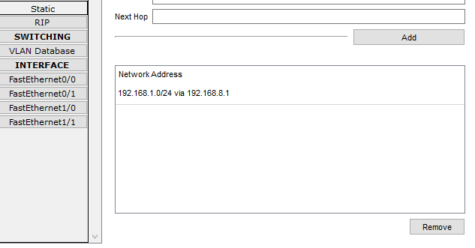

**For Router 4:**

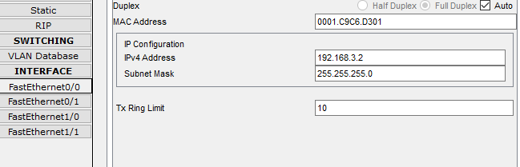

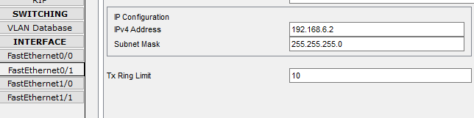

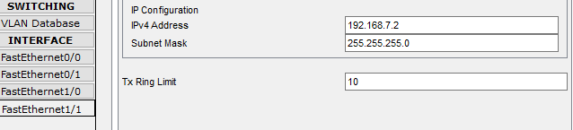

**STATIC ROUTING:**

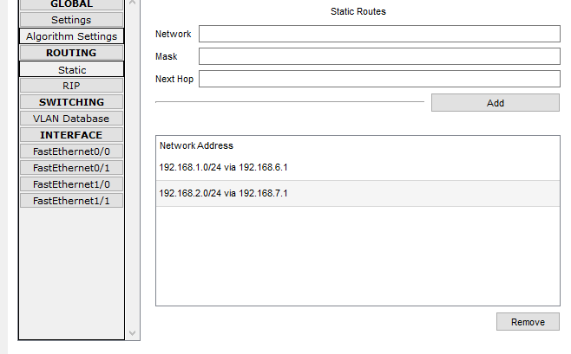

**Now Check your connection and use helper IDs**